MantechHelpDesk

Installation Guide

Faculty : Hoang Duc Quang
Batch No : F2-11-1208-T1
Group No : 01
Student :

No | Full Name | Roll No
1 | Le Quoc Truong | Student721753
2 | Hoang Hoai Bao | Student685946
3 | Nguyen Ngoc Anh | Student686040
4 | Nguyen Duong Kim Hao | Student646103
5 | Phung Do Hoang Hung | Student691839

Table of Contents
How to install database? 3
How to configure datasource? 3
How to run the project from *.EAR file? 7
How to import source codes to Netbeans IDE? 8
How to login to MantechHelpDesk system? 9

How to install database?

The MantechHelpDesk system needs to have a database to store the information of complaints as well as other information to control the whole activity of the system.

To install the database for Mantech system, you have to have the SQL Server (from 2008 or later), and it is the best to have SQL Server 2012 installed on your machine already.

Open the SQL Server Management Studio and make the connection to the database server. Please use the administration account during your installation of SQL Server (normally username/password = sa/123 or sa/123456)

If you have no SQL Server database on your own machine now, then you need to have a database SQL Server from the host. Don’t worry because the MantechHelpDesk system has also a TEMPORARY database server for you to test the application.

Information of SQL Server provided by MantechHelpDesk system:
- Server: 112.78.2.76
- Username/password: bie40d12_eProject/5deaj6RKeZNZtIJE

Unzip the file Group1-MantechHelpDesk.zip. Open the Final-v10.sql file in the directory Group1-MantechHelpDesk\program\db.
Run this SQL file to create a database and tables to start to use the application.

How to configure datasource?

The MantechHelpDesk runs on Jboss server, so you have to configure the datasource for the application. To prepare the datasource, you have to install Jboss server on your own machine.

To have the Jboss server installed on your machine, you can download Jboss from http://jbossas.jboss.org/downloads/ and please go through the documentation site to install it first at http://jbossas.jboss.org/docs

After install Jboss, you will have the directory on your machine to contain the source from where you can start the Jboss Application Server.

Go to the folder that contains the Jboss sources. <Your path to Jboss>\bin, open a Command Prompt from this location by Shilf + Right-clicking on this bin folder, choose Open window command here.

Run the standalone.bat file from this command prompt. That’s all you need to start the Jboss server. However, you have to create an administrator role for Jboss. See how to create this via https://docs.jboss.org/author/display/AS71/add-user+utility . In windows, please run add-user.bat file.

After starting Jboss successfully, please open the management link: http://localhost:9990/console/App.html

Input username and password of administrator role to login the system

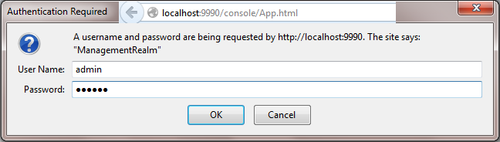

Follow the steps by Clicking Runtime -> Management Deployments -> Add Contents to deploy the JDBC driver to connect to database:

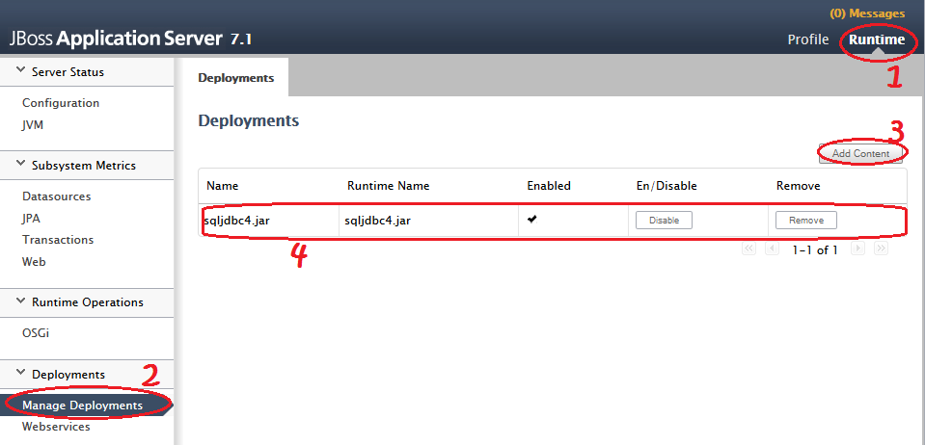

Remember, we use the 4th sort of Database Driver. You can download this *.jar file from http://msdn.microsoft.com/en-us/sqlserver/aa937724.aspx

After that, you follow the steps below to add a datasource to use the sqljdbc4.jar to connect to SQL Server:

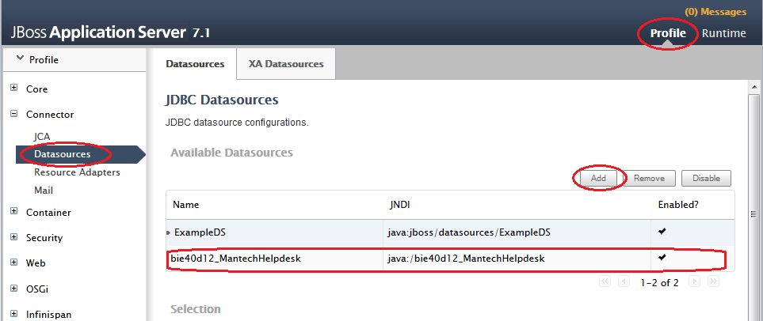

When click Add, you have to fill up the information to establish the connection

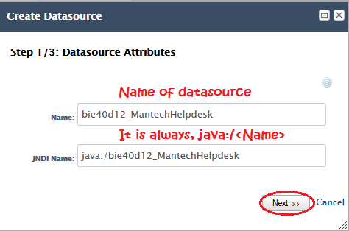

Click Next, to choose the types of driver, choose sqljdbc4.jar as you’ve already installed above, click Done.

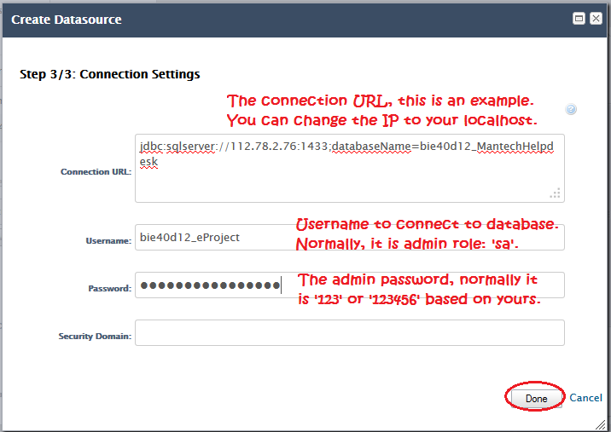

Enable the datasource and test the connection

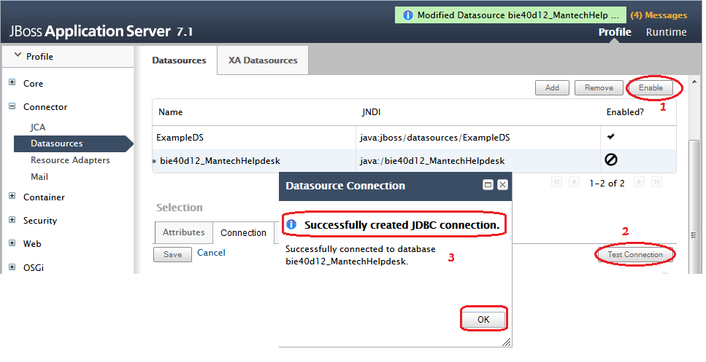

How to run the project from *.EAR file?

To run the project, you have to deploy the *.EAR files on Jboss system. You can find the *.EAR file in the directory of the zip file: Group1-MantechHelpDesk\program\ear

Folow the steps:

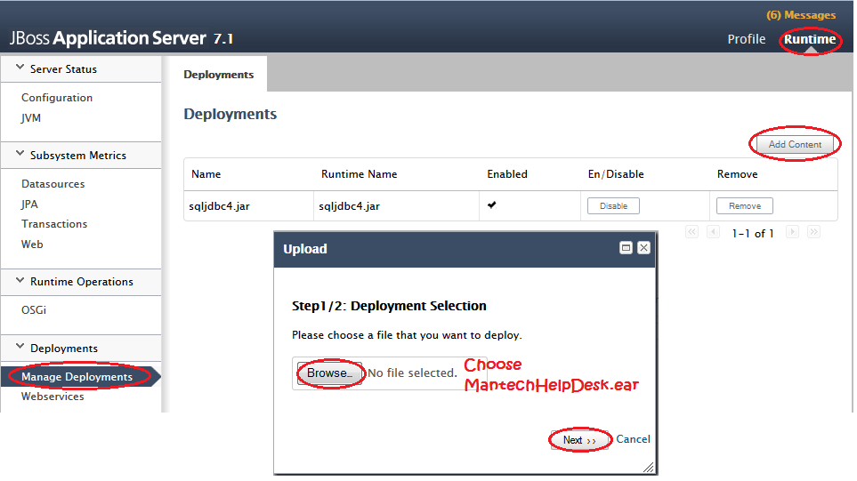

Click Next and follow Next to the end. Enable the application and run the project.

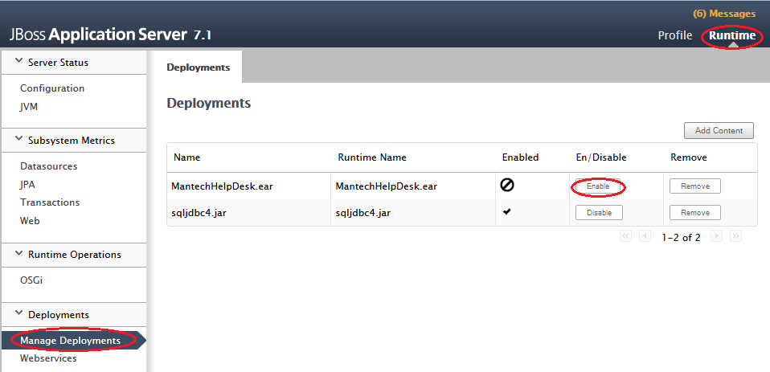

To run the project, you run via link: http://localhost:8080/MantechHelpDesk-war/
If successfully, the login screen to MantechHelpDesk system will display as the following:

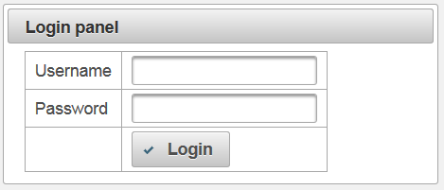

How to import source codes to Netbeans IDE?

Other than that, the Zip file also includes the source codes of the MantechHelpDesk system so that you can use Netbeans IDE to import the project and to runthe project from there.

Open Netbeans IDE, please use Netbeans version from 7.4. From the Netbeans IDE window, choose File -> Open Project… and point to the location of project’s source code to pick it up at Group1-MantechHelpDesk\source code\mantechhelpdesk

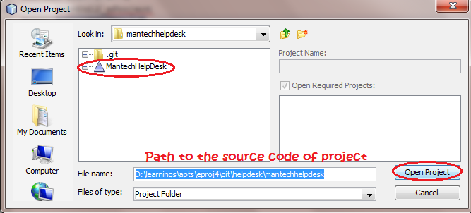

Then you will find 3 projects imported into your Netbeans IDE

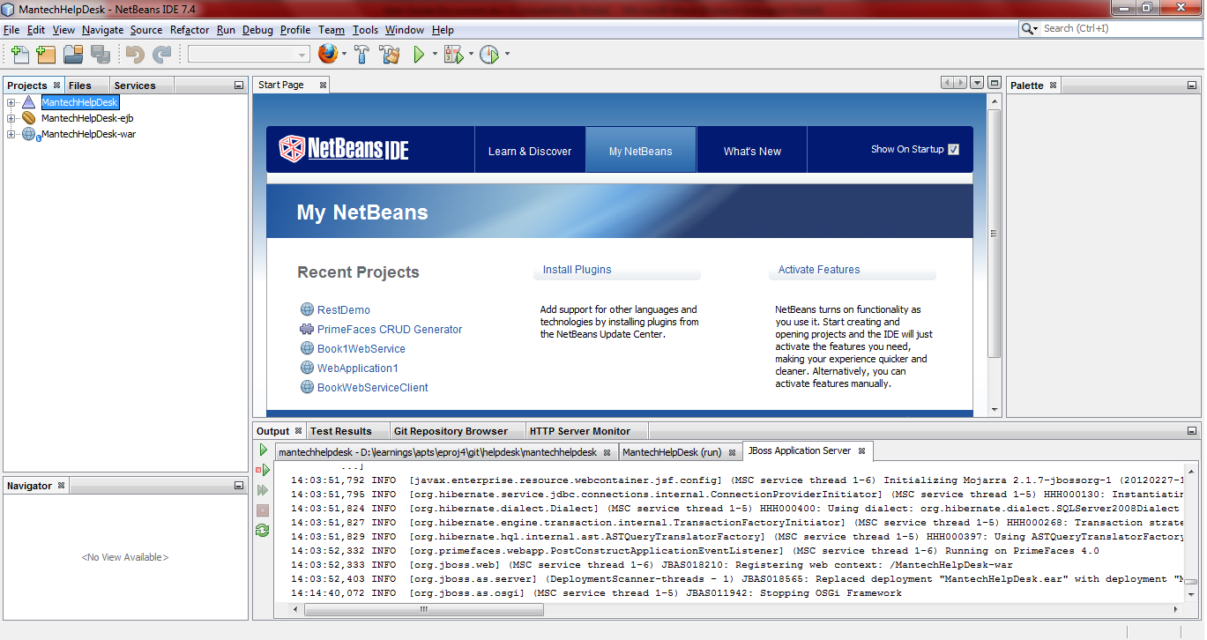

How to login to MantechHelpDesk system?

To login to the MantechHelpDesk system, you have to have the account registered to the system first. The system does not allow the anomyous account to visit.

The available accounts and roles for you to login are defined in the *.SQL script file, Final-v10.sql. They are as below:

For Administrator role:
- Username/password: truong/1
- Activities allowed:
  - Create/Update/Delete other user accounts.
  - See the histories of other account doing on the system like to see the latest complaints created by the user, to see what the changes or updates on the complaints from the technicians…
  - To assign the complaints to the technician.
  - To update status of the complaints.
  - To view the report from selecting different kinds.
  - To read FAQs, read technical article and rate the technicial articles.

For Technician role:
- Username/password: hao2/1 or bao2/1 or anh2/1 or tech/1
- Activities allowed:
  - To View all assignments from Administrator.
  - To resolve the complaints.
  - To update the complaints status, update reason, update the category in case the user put wrong category…
  - To write technicial articles
  - Not allowed to rate the articles because the system to avoid him to rate for himself.
  - To read FAQs…

For Registered role:
- Username/password: hao/1 or bao/1 or anh/1
- Activities allowed:
  - To create a new complaints about the issues, problems from Hardware or Software failures.
  - To View the complaints details.
  - Not to update/or delete the complaints. This will be update by the database administrator for security.
  - To resend the notifications to the Adminstrator again if the complaint is not taken into account to resolve more than 2 days.
  - To read and rate the technical article.

